Project Design Phase
Solution Architecture
Date | 01 October 2026
Team ID | SWTID-2026-8116
Project Name | AI FitTrack API
Maximum Marks | 4 Marks

Solution Architecture:
Solution architecture bridges the gap between the business problem and the technology solution. For AI FitTrack API it aims to:
- Give small development teams personalised coaching without in-house ML.
- Describe the structure, components and behaviour of the system for stakeholders.
- Define features, development phases and requirements (see Solution Requirements and Project Planning).
- Provide the specification by which the solution is built, managed and delivered.
Solution Architecture Diagram:
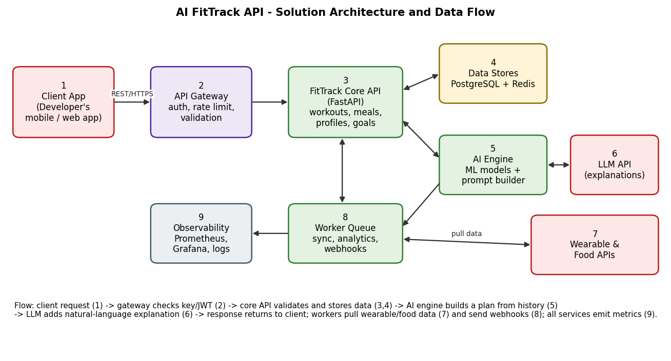
Figure 1: Architecture and data flow of AI FitTrack API
Component responsibilities
No. | Component | Responsibility
1 | Client App | The developer's mobile or web app; sends requests with an API key or JWT.
2 | API Gateway | TLS termination, authentication, rate limiting, request validation.
3 | FitTrack Core API | Business logic for profiles, workouts, nutrition, goals, consent, export and deletion.
4 | Data Stores | PostgreSQL for records; Redis for cache, rate limits and job queue; S3 for files.
5 | AI Engine | Turns user history into features, runs models, builds the plan and the prompt for explanations.
6 | LLM API | Writes plain-language explanations; its output is checked against safety rules before being returned.
7 | Wearable & Food APIs | External sources for activity, sleep and nutrition data.
8 | Worker Queue | Scheduled syncs, analytics, webhook delivery and retries.
9 | Observability | Metrics, logs and alerts (Prometheus, Grafana, centralised logs).
Key design decisions
- The AI engine uses trained models for numbers (load, calories) and the LLM only for wording, so plans stay consistent and testable.
- Heavy and slow work is queued, so API latency stays low even when a wearable provider is slow.
- Personal data is encrypted and tied to consent records; export and delete are first-class endpoints.
- Outputs carry a not-medical-advice notice, and unusual inputs (e.g. extreme calorie targets) are refused.

